Homework 6

ID 38

1. Describe the null hypotheses to which the p-values given in Table 3.4 correspond. Explain what conclusions you can draw based on these p-values. Your explanation should be phrased in terms of sales, TV, radio, and newspaper, rather than in terms of the coefficients of the linear model.

Solutions:

For TV:

$H_{0}=$ For a given radio and newspaper ads, TV ads do not influence sales

For radio:

$H_{0}=$ For a given TV and newspaper ads, radio ads do not influence sales

For newspaper:

$H_{0}=$ For a given radio and TV ads, newspaper ads do not influence sales

Obviously, the p-values of TV and radio is fairly low which indicates that we reject their null hypotheses. However, the high p-value of newspaper means the we cannot reject its null hypothesis.

3.8

1. Use the lm() function to perform a simple linear regression with mpg as the response and horsepower as the predictor. Use the summary() function to print the results. Comment on the output. For example:

Solution: $lm.fit = lm\left(mpg\sim horsepower,data=Auto\right)$

$summary(lm.fit)$

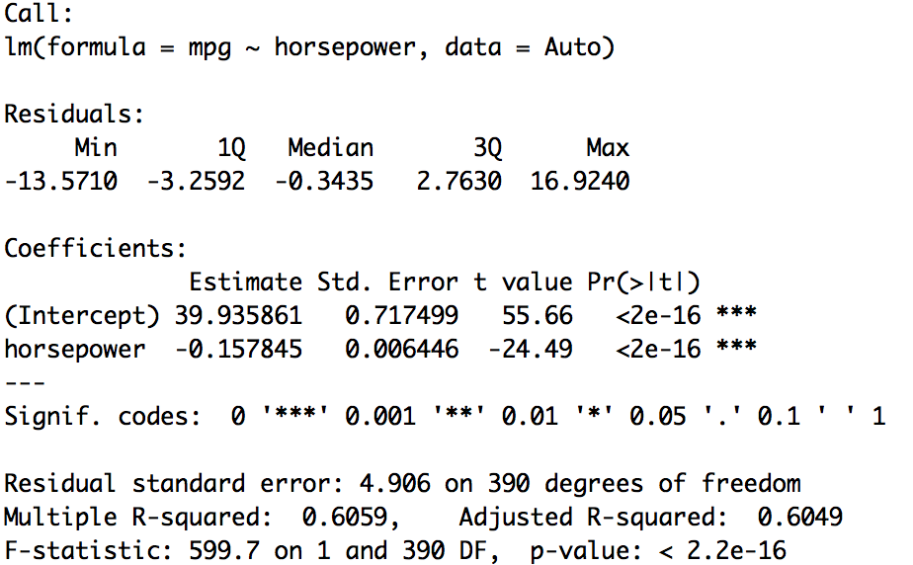

1. Yes, there is a relationship between the predictor and the response.
2. The p-value is close to 0 which means a strong relationship.
3. The negative coefficient means the negative relationship.
4. The predicted mpg associated with a horsepower of 98 is 24.46708.

The associated 95 % confidence interval is between 23.973 and 24.961.

The associated 95 % prediction interval is between 14.809 and 34.125.

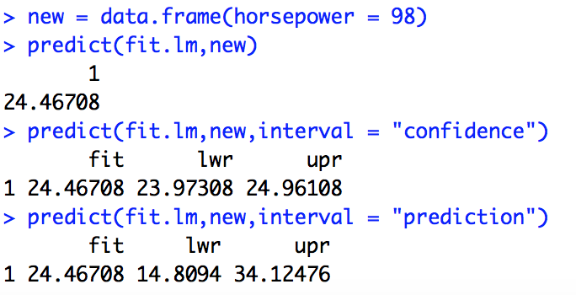



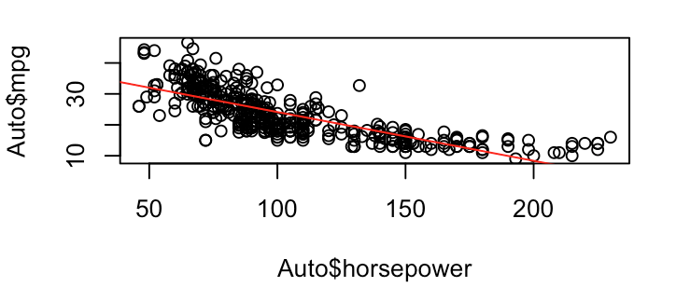



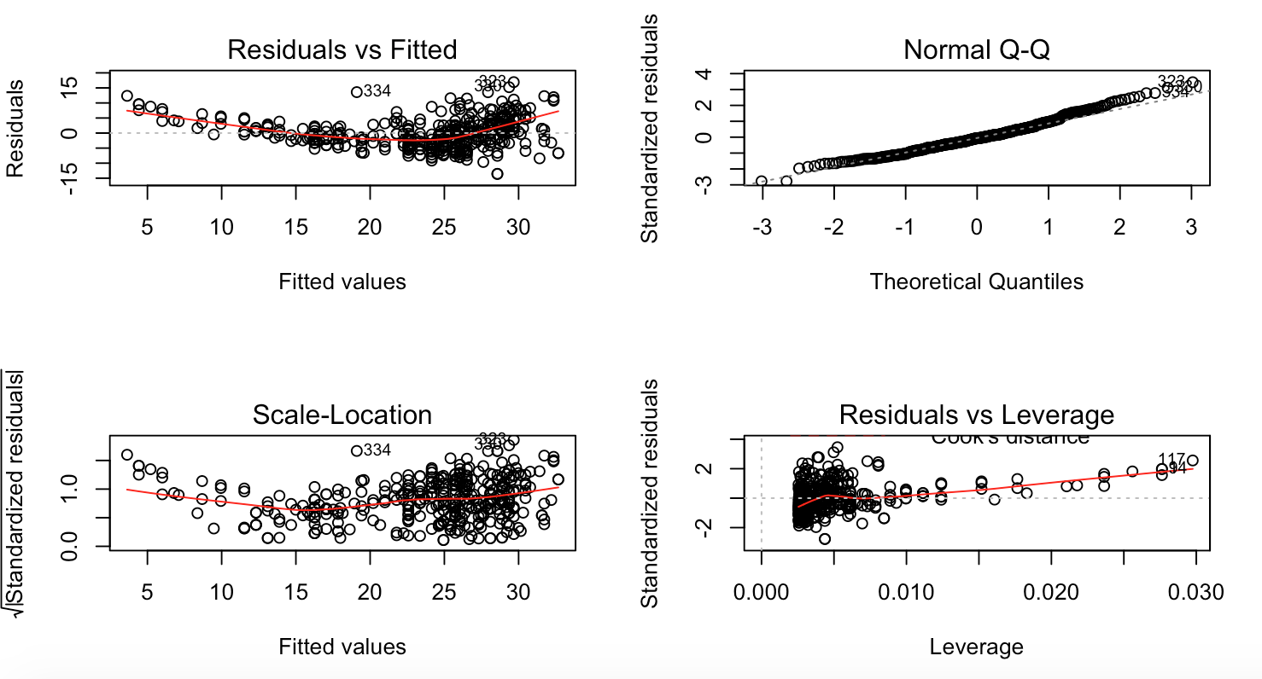

From the residuals vs fitted plot, we can see that the relationship is non-linear.